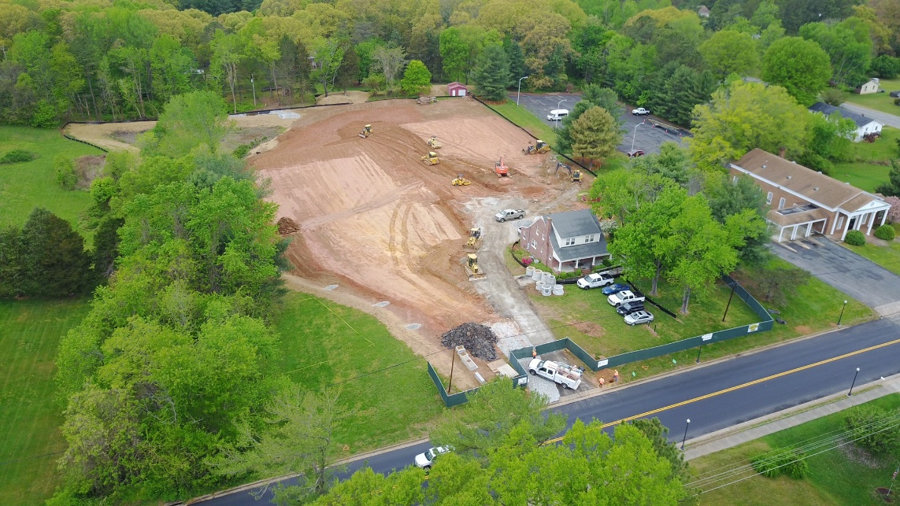

Start date: April 2017
Completion Date: May 2018
Final Contract Amount: $623,993.13

Contractor: Hourigan Construction
Risks:
- The drain field was not of sufficient size to accommodate both the existing facility
and the new one.
How we overcame, orchestrated outcome:
Assisted in the design of a pump lift station and performed direction boring and navigation of approximately 980 LF of force main going under 2 lanes of traffic on Route 6.
