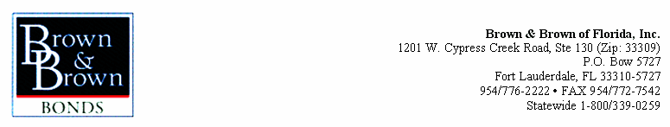

July 18, 2011

Lotspeich Co. of Florida, Inc
6351 N.W. 28th Way, Suite A
Fort Lauderdale, FL 33309

RE: Bondability Letter

To Whom It May Concern:

Per your request for evidence of bondability, this letter is to advise you that Lotspeich Co. of Florida, Inc. is set up for bonding with Travelers Casualty and Surety Company of America, whose A.M. Best rating is A+ with a financial size category of XIV.

Our company has bonded Lotspeich Co. of Florida, Inc. in excess of 20 years and have found them to be an outstanding contractor, with a good reputation in the construction industry. Based on their past experience, we have considered single jobs of $10,000,000.00 with an aggregate program of $30,000,000.00 but this should not be construed as a maximum program amount.

If Lotspeich Co. of Florida, Inc. has a low bid acceptable to all parties, if adequate financing is confirmed, and if all other normal requirements are met, with surety approval, we look forward to providing a final bond on this project.

As this is a letter of recommendation, and not a bid bond, Brown & Brown of Florida, Inc., Travelers Casualty and Surety Company of America, their agents and owners accept no liability for its content. The Surety reserves the right to review each submission and base their final decision upon conditions that exist at the time of request.

If we can be of additional assistance, please feel free to give us a call.

Sincerely,

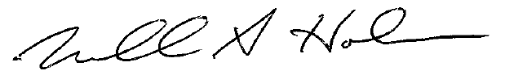

Michael A. Holmes, ARM, CIC
Senior Vice President, Surety Division

Expiration: July 14, 2013

